Teacher Documentation

Doorway Text Type

and Teipio Testun

© The Doorway Accesible Software Trust 2022

Contents

Introduction 4

Support and Accessibility 4

Text-to-speech Voices 5

Installing the Nia voice for Microsoft Edge 5

Who is Teipio Testun for? 7

What is Touch Typing? 7

Language and Options 7

Getting Started 8

More about the Practice Keyboard 8

Exercises 9

Home Key exercises (*Y rhes gartref)* 9

Welsh Alphabet 10

Capital Letters (*Priflythennau)* 10

Accented characters *To Bach* â, ê, î, ô, û, ŵ, ŷ 11

Punctuation and Symbols 12

Accented characters ï, ö, ü, ì, á, í 13

Welsh text and Sentences 14

Reviewing a Learner’s Progress. 14

Options (*Opsiynau*) 14

Show Keyboard - *Dangos bysellfwrdd* 14

Show Hands - *Dangos dwylo* 15

Allow Line Skip - *Caniatáu sgipio llinell* 15

Show Keyboard in Lowercase - *Dangos bysellfwrdd mewn llythrennau bach* 15

Speak Target Letters - *Darllen llythrennau targed* 15

Speak Key Pressed - *Darllen y fysell a bwyswyd* 15

Speak Finger Prompts - *Darllen anogwr bys* 16

Internal Screen Reader Speech - *Llais darllenydd sgrîn mewnol* 16

Main Voice, Secondary voice – *llais cadarnhaol, llais negyddol* 16

Highlight colour and Background style 16

Other Options and Navigation 17

Keyboard Navigation 17

Keyboard Input Method 18

To Bach 18

Accessibility Features 19

Scoring, Accuracy and Words per minute 19

Caps Lock 19

Single Handed Typing 20

Sticky Keys – *Bysellau Gludiog* 21

Single-Handed Exercises 22

The role of the teacher 22

Finally 23

# Introduction

This guide for teachers aims to help support any child, especially one who may have Visual Impairment or other additional needs, to learn to type with Teipio Testun.

Learning to type at the keyboard is a valuable skill for any modern person, but especially so for those with a visual impairment.

Teipio Testun is a web-based activity to support Welsh speakers in learning to touch type. It does this through a series of gradual exercises. It presents the learner with a line of text to be typed; an indication on a keyboard of the key to be pressed and an indication of the finger to use. It offers additional support at key points such as learning to type capital letters and typing accented letters such as â é à.

Teipio Testun is based on Doorway Text Type, the English language typing tutor available on the website [www.doorwayonline.org.uk](http://www.doorwayonline.org.uk/)

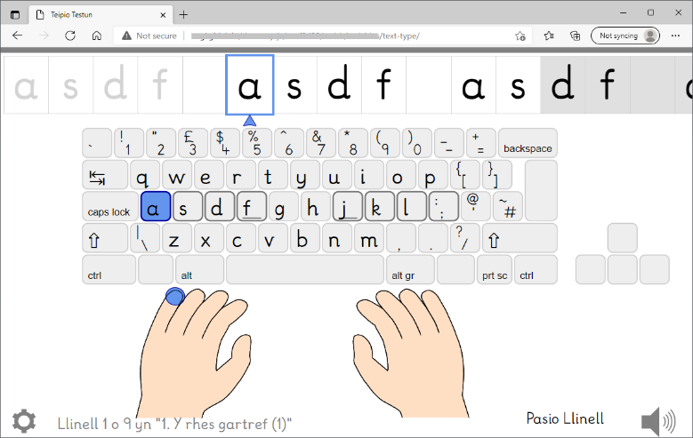

## Support and Accessibility

Support from a teacher is important for young users getting started. It is not realistic for a child with accessibility needs to find Text Type/Teipio Testun themselves, set it up perfectly, and use it, without even knowing the keyboard initially.

Accessibility is a priority. Teipio Testun has been designed to support visually impaired learners as far as it is possible for a computer application. These features include:

* Welsh and English language translations and typing exercises.
* Typing technique for single handed users as well as the two-handed.
* Simple screen layout with large, high-contrast elements.
* Full-screen design to minimise distractions.
* An easy-to-read font, based on handwriting taught in schools.
* Adjustable size of the text in the exercises.
* Dark or light screen background colours.
* Red, green or blue colours for highlights and prompts.
* Speech prompting the next letter, which finger to use, and reporting an incorrect keypress.
* "Screen reader” that speaks text in the web browser.
* Access to all the features using standard keys for web browsing

External assistive software is complicated for young users, introducing layers of keyboard input, modified screen display, and a lot of spoken detail. External screen magnifiers, and screen readers, are unnecessary and unhelpful as Text Type/Teipio Testun has the above features, which are easier to use.

It is impossible to touch type without a proper physical keyboard. Soft keyboards on touch screen devices (also called on screen keyboards, or virtual keyboards) should be avoided.

## Text-to-speech Voices

Text Type/Teipio Testun is designed to be accessible as possible to low vision learners. On-screen text is accessible by being spoken with a Text to Speech (TTS) voice. However not all voices are available in all web browsers, and there is a very limited choice for Welsh, at the time of writing this (early 2022).

During the exercises, Teipio Testun adjusts the pronunciation of single letters to be recognisable and to work within the technical limitations of the voices. However, this may not be as taught in Welsh classrooms.

Historically, Windows computers could install SAPI voices and two Welsh voices were available, called Ivona Gwyneth and Geraint. However, these no longer appear to be supported by the manufacturer, and some web browsers ignore SAPI voices even if available.

**Microsoft Edge** is currently the only browser with a Welsh voice, called Microsoft Nia Online. See below how to install the Nia voice.

**Google Chrome** does not have a Welsh voice yet, and does not recognise SAPI voices even if you have them installed.

**Firefox** is not officially supported by Text Type/Teipo Testun, but should work and supports SAPI voices, such as Ivona Gwyneth and Geraint.

**ChromeBooks** running ChromeOS have no useful Welsh voices, as far as we are aware.

Installing the Nia voice for Microsoft Edge  
Go to Microsoft Windows -> Settings -> Time and Language -> Language

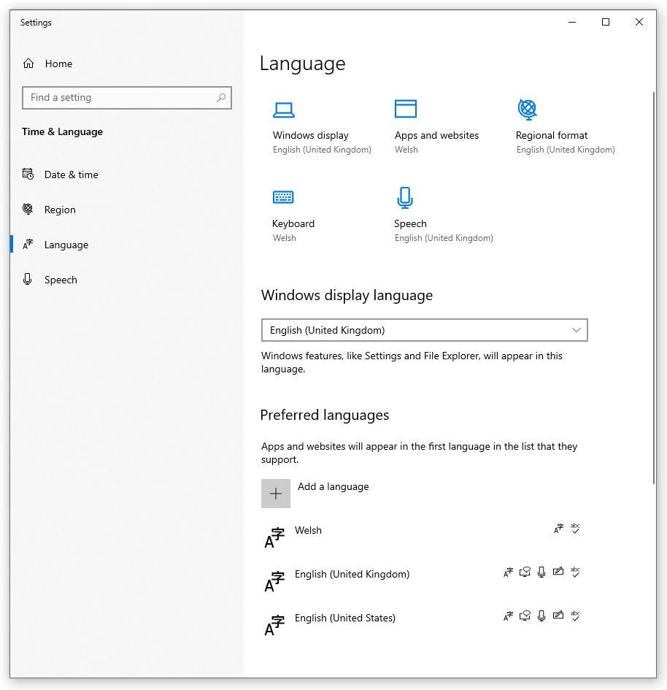

If you don’t already have it, add the language Welsh or Cymraeg.

In the Microsoft Edge browser, go to Settings, then choose “Languages” on the list of categories on the left. Add the language Welsh.

Edge will take a while to install the language features. However, it may be blocked entirely by your corporate IT policies. Unfortunately, there seems to be no confirmation from Edge that installation is proceeding or otherwise.

Please wait an hour then restart your computer. When you choose the Welsh language in Teipio Testun, you may see that the Microsoft Nia voice is available.

By the time you read this, the instructions above may be out of date or incorrect. Installation of Microsoft features is outside the scope of Teipio Testun itself. Please contact your IT department if you have questions about this.

## Who is Text Type/Teipio Testun for?

Teipio Testun is a touch-typing tutor for young learners. It aims, in particular, to support visually impaired learners; from those who can benefit from its clear presentation and large size target text, to those who need the target text enlarged even further, to those who need text to speech feedback and key-driven browser navigation to work through the exercises.

Despite this level of assistance within Text Type/Teipio Testun cannot be used by learners without support from a teacher. The teacher’s role is discussed at the end of this document.

Text Type/Teipio Testun is not intended for typists to practise once they can sustain near 100% accuracy and 16 words per mnute.

## What is Touch Typing?

Touch typing is the skill of typing text at the keyboard, accurately, with all fingers and without looking at the keyboard. With practice, this will become faster than the learner’s handwriting.

The QWERTY keyboard was designed to minimise collisions between consecutive keys on a manual typewriter. Even though the mechanical problem is no longer relevant, QWERTY has become so embedded in our world that it is impractical to change.

There are some important points that are not as widely understood as it should be. Touch Typing is a motor skill, in the same way as mastering a musical instrument or even riding a bike.

* Once learnt, the typist has no need to look at the keyboard.
* Once learnt, touch typing is a skill the typist will not forget.
* Accuracy is far more important than typing speed. Words per minute scores are not reported until all the letters have been learnt. It is hard to unlearn an incorrect motor habit.
* Typing while peeking at the keys doesn't lead to the mastery of touch-typing. Touch typing is an essential skill for a visually impaired learner. In a way it is easier for them as they are less likely or unable to look at the keys. A good idea for the fully sighted learner is to cover their hands with a light cloth. It really works!

The exercises introduce the letters gradually, so that learners practising regularly should become proficient touch typists.

## Language and Options

The first screen of Text Type/Teipio Testun allows users to choose the language between Welsh and English, and to choose whether they will betyping with two hands, or one. This guide is written in English but the translations used for important terms are also given here in Welsh (*Cymraeg*).

The second screen offers a range of options and exercises including the practice keyboard. These are discussed in more detail, below.

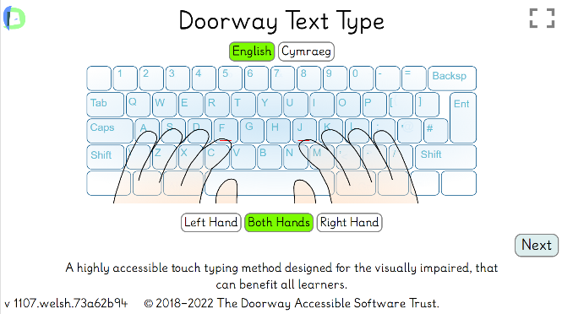 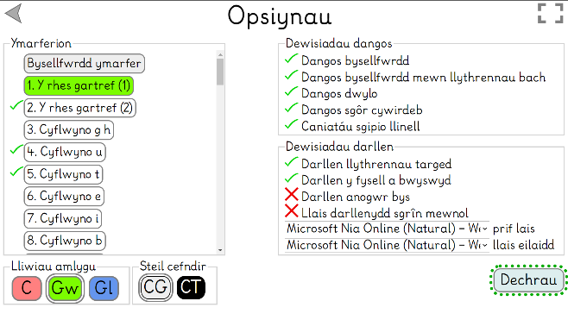

## Getting Started

A complete beginner should not start on the real keyboard. Rather, the learner puts their hands on the desk as if on a keyboard. The teacher uses a pencil or similar to touch their finger nails, while saying these letters: A S D F F D S A and semi-colon L K J J K L semi-colon. The pupil repeats these, until they are learnt.

Text Type/Teipio Testun has a “Practice Keyboard” (*Bysellfwrdd ymarfer* in Welsh), which does not prompt you to type any particular letter, but rather shows you which keys you have pressed (and speaks the letters too if that option is enabled).

Using the practice keyboard, the learner is guided to putting their fingers on the keys. A Learner with VI difficulties will need to have their hands guided. They should be taught to find the ridge (physically raised line) on the F key and the J key with their first fingers. Every QWERTY keyboard should have these. The ridge on F and J can be hard for some learners to feel. It may be necessary for an adult to add a tactile feature to the keys. If you have a sheet of orange bumper stops from RNIB, trim down two of these and stick them over the ridges.

The learner should then spread out their finger to the other keys. Ask if they can make the computer say "A S D F ". Then how about “J K L *hanner colon* " ?

Now you can add the spacebar, pressing it with a thumb. Can you make the computer say, " F D S A *bwlch* A S D F " ? Then "J K L *hanner colon* *bwlch* *hanner colon* J K L".

Now can you stretch out your right pinkie for “*bysell enter*”

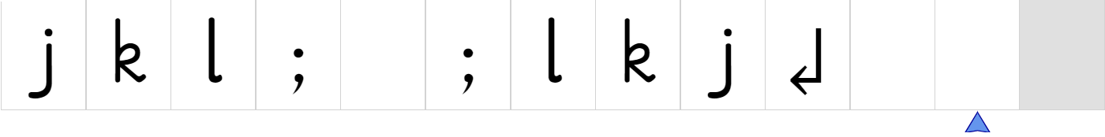

## More about the Practice Keyboard

The Practice Keyboard has a very useful function, in allowing learners to practise the use of important keys needed for navigating Text Type/ Teipio Testun without using the mouse. The names of these keys are displayed in the text line and are spoken.

The screen shot below shows the practice keyboard after typing Enter, Tab, Shift, Up Arrow, Down Arrow, Left Arrow, Right Arrow, Alt Gr, Backspace, Delete and Space.

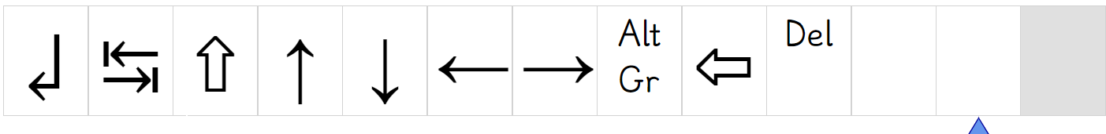

Several keys can be practised but are not taught in the exercises, like Backspace, Delete, Home and Page Down. However some keys trigger actions on your computer or web browser which interfere with Teipio Testun, and therefore are not recommended to practise. For example F5 reloads the web page and restarts it from the beginning.

# Exercises

When the learner is comfortable with the Keys A S D F J K L ; space bar as well as the little finger stretch to Enter then they can start on the main exercises.

The exercises are a gentle progression through the stages of learning to type. Each of these stages requires attention from a teacher to ensure that the learner does not start off down the wrong track.

1. home keys
2. rest of the native alphabet
3. capital letters
4. letters not used in Welsh
5. accented characters â, ê, î, ô, û, ŵ, ý
6. punctuation and symbols
7. less common accented characters ï, ö, á, í, à

The exercises are for practice. They do not take place of a teacher. The learner will need to be supervised. This supervision required should lighten, as they acquire more skills.

The exact number of exercises and sequence varies between English and Welsh. The earlier exercises vary for left-handed typists, right-handed typists and two-handed typists. Welsh accented characters are only taught when you have chosen to use Teipio Testun in Welsh.

## Home Key exercises (*Y rhes gartref)*

The home keys are A S D F and J K L ; (including the semicolon). It is essential that two-handed learners are able to locate the ridges on F and J, then put their fingers on each of these keys, keeping them in position. See the section below for single-handed learners. It is worth spending time on the practice keyboard before starting with the first lesson *1. Y rhes gartref*.

You can ask the learner to place their fingers on the home keys, then you tap the nail of the fingers as you say A S D F F D S A This should be at slow rate but at a regular rhythm so that the learner understands that typing at a beat is a good way to learn. Then the learner types to your tapping their fingernails.

The learner is ready to move on when they are comfortable with the current exercise. This is usually indicated by an accuracy score of 90% or better, in the score sheet at the end of each exercise. Allowing a learner to move on to the next exercise without sufficient mastery of the current one, will lead to frustration later.

Exercises 3-15 introduce the remaining Welsh letters to the learner's repertoire, one or two letters per exercise. Again, progress should be steady, not advancing before at least 90% accuracy has been achieved.

## Welsh Alphabet

The Welsh language is taught in schools with a different alphabet from English. Some letters are not used in native Welsh, including j, q, k, v, x, z. Other digraphs are taught as letters and have their own sounds: ch, dd, ff, ll, ng, ph, rh, th.

Teipio Testun teaches single typed characters rather than single sounds or letters. The digraph letters are treated as two single characters because Teipio Testun is about typing, not about reading or speaking.

Those English letters which are not used in Welsh, are taught after the capital letters. They are included for experience of typing English words.

## Capital Letters (*Priflythennau)*

Once all the Welsh letter keys have been established, we have a tutorial at exercise 16. Capital letters are the first characters that require two key presses as the same time: Shift and the letter key.

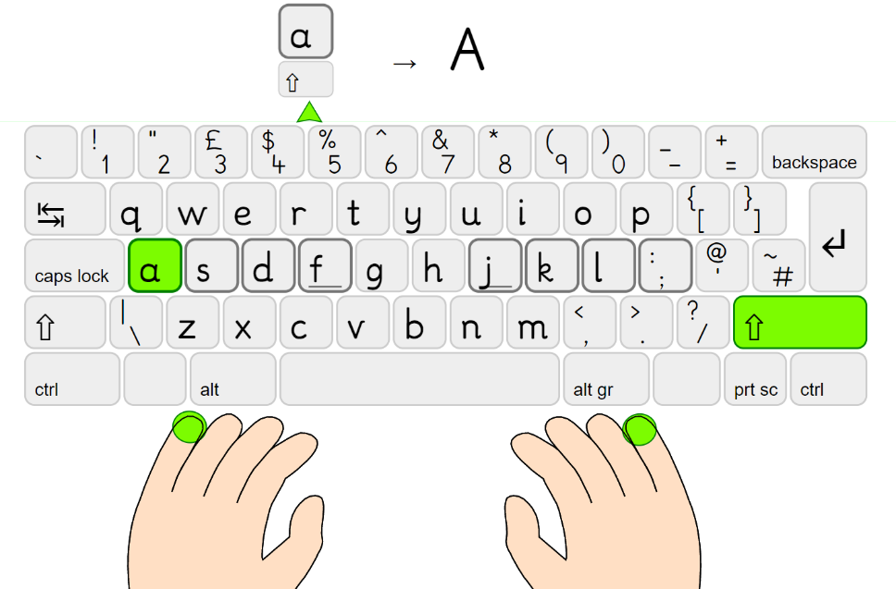

This tutorial demonstrates that:

* Of the two keys, press and hold down Shift first, then briefly press the letter.
* There are two shift keys, left and right. You should press the Shift key from the opposite hand you will use to press the letter key. In this way, the learner can continue touch typing, entering text without peeking at the keys.

Exercise 16 shows exactly which key should be pressed and released, but it does not give a lot of practice. The capital letter tutorial only appears in the Welsh language.

Letters on the keyboard which are not used in native Welsh language (J K Z Q X V), are introduced after this.

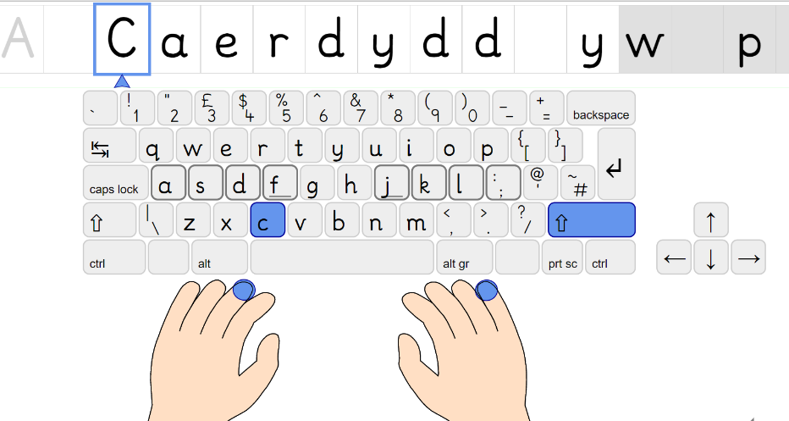

Exercises 17-19 give plenty of practice at producing capital letters. First with the right Shift held down (Ex 17), then the right Shift (Exercise 18). Finally, the shift key to be pressed alternates between hands (Ex 20).

## Accented characters *To Bach* â, ê, î, ô, û, ŵ, ŷ

Typing Welsh accented characters is not straightforward. You should set the computer operating system to the Welsh regional input method. On Microsoft Windows, install and choose CYM. On Google Chromebooks, the GB input region supports Welsh characters. See below for more about regional input methods.

Teipio Testun will take the learner through the steps of mastering entry of accented characters â, ê, î, ô, û, ŵ, ŷ in a tutorial at Ex 31 and the following four exercises. For these characters, a sequence of key combinations is required. On a Microsoft Windows computer in the CYM region, first you have to hold down Alt Gr with your right thumb then briefly press 6, stretching the first finger of your left hand. Then release these two keys and type the main letter, for example A.

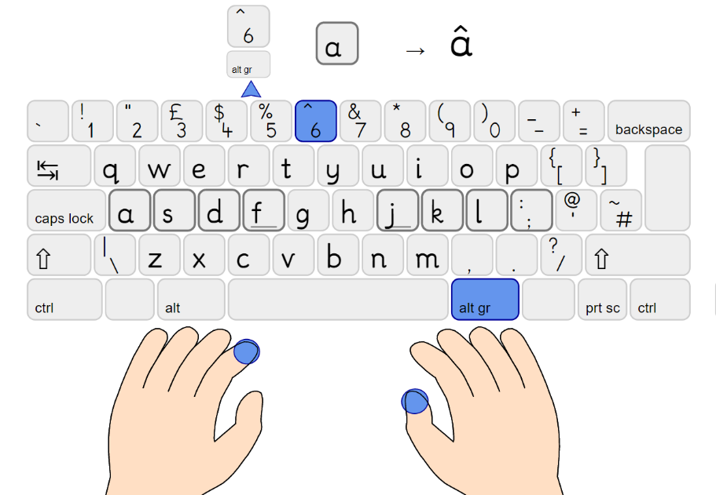

Normally, the 6 key is pressed by the first finger of the right hand. To keep to the principle of touch typing, we use the first finger of the left hand to type 6 when you are also holding down AltGr. This is no more of a stretch for that finger, but an additional key to cover.

Extra practice can be given in the Practice Keyboard, which will show and say the keys pressed including Alt Gr and 6, then the resulting accented letter.

## Punctuation and Symbols

Less common punctuation and symbols are introduced and practised in the next exercises. The names are spoken if a TTS voice is enabled.

|  |  |  |  |
| --- | --- | --- | --- |
| Exercise | Character | Welsh name | English name |
| 40. Marciau lleferydd “ | “ ‘ | Dyfynodau | Quotation marks |
| 41. Jôcs 42. Mwy o Jôcs | ?  ! | marc cwestiwn  ebychnod | Question mark  Exclamation mark |
| 43. Ebost: @  44, 45, 46 | @ | At | At |
| 55. Dyddiadau a Phenillion // | / | blaenslaes | forward slash |
| 56. Cantorion Cymreig ( ) | (  ) | agor cromfachau  cau cromfachau | open brackets  close brackets |
| 60. Arian £ $ € | £  $  € | punt  doler  ewro | pound  dollar  euro |
| 61. Cyflwyno & * # | &  *  # | ampersand  serennig  hash nod | ampersand  asterisk  hash |
| 62. Symbolau < > % | <  >  % | yn llai na  yn fwy na  y cant | less than  greater than  percent |
| 63. Symbolau - = + | -  =  + | llinell doriad  hafal  plws | dash  equals  plus |

The amount of attention given to these exercises is at the discretion of the teacher. This list does not cover all the possible symbols that can be created via the keyboard. Others can be practised using the Practice Keyboard, for example | \ [ ] { } ~ _`¬

Other keys on the keyboard such as Escape and Windows key are outside the scope of Teipio Testun and may cause confusing actions on the computer or browser which interfere and cannot be managed by Teipio Testun.

## Accented characters ï, ö, ü, ì, á, í

Full instructions are given in the tutorial exercise 57. You should achieve near to 100% before advancing to exercises 58 and 59 to use these vowels in sentences.

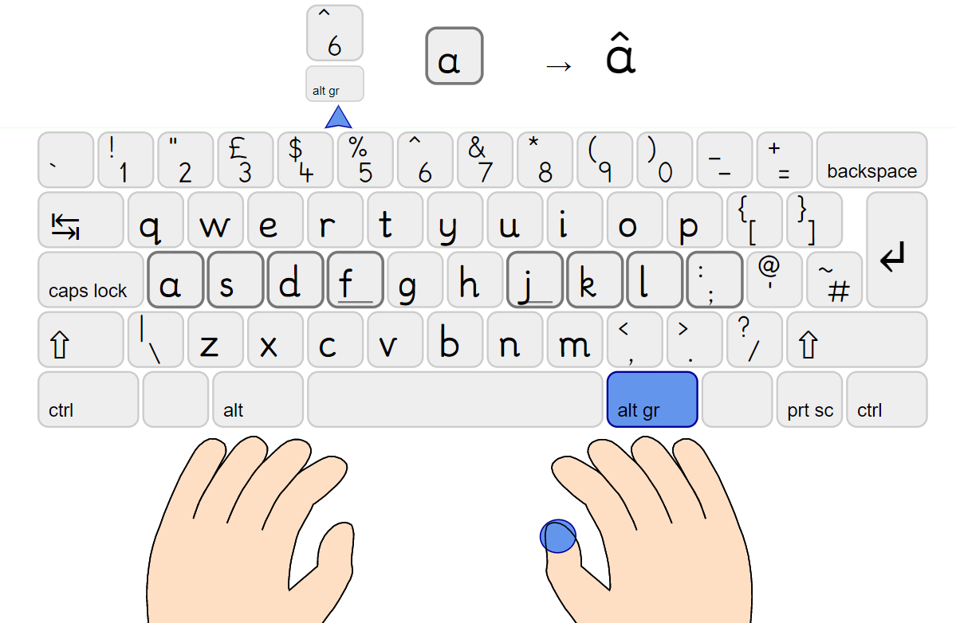

The two dots over a vowel in ï ö ü are produced on Windows computers by holding down Alt Gr, pressing 2, releasing them then pressing the letter.

The grave accent over a vowel like ì is produced on Windows in Welsh regional input by pressing and releasing backtick, then the vowel letter. The backtick key may also have the symbol ¬ on your physical keyboard.

The acute accent is produced by holding Alt Gr and pressing the vowel. The vowel á can be produced with each hand on its side of the keyboard. However í is problematic. It can be done with one hand, the thumb on the Alt Gr key and first finger pressing I.

## Welsh text and Sentences

Exercises 46 onwards include Welsh text and cultural content, mixed in between the rare punctuation and symbols.

## Reviewing a Learner’s Progress.

A teacher can quickly view progress by looking at the symbol beside the exercises in the menu. The past performance is stored in the learner’s profile and is displayed thus;  
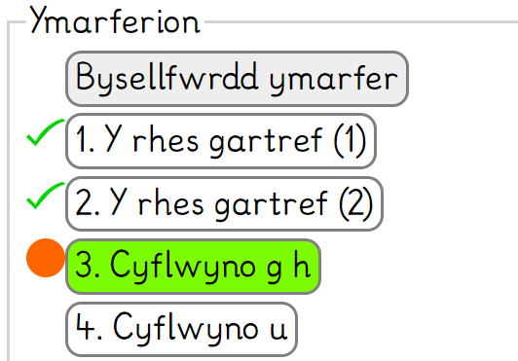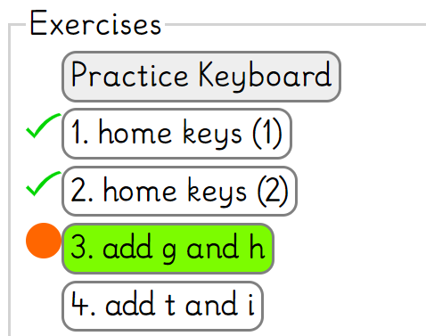

* A tick means it has been completed with good accuracy.
* A circle means it has been completed with moderate accuracy.
* No mark means it has not been completed or completed with only poor accuracy.

# Options (*Opsiynau*)

### Show Keyboard - *Dangos bysellfwrdd*

The keyboard is one of three main elements on the main typing screen, along with the hands and the target text. It highlights the next key to be pressed.

If you want even larger text or a simpler screen layout, with fewer characters, you can disable this option.

### Show Hands - *Dangos dwylo*

The hands show you how to hold your hands, and which finger to use next. Removing this option will increase the size of the main target text further.

With neither Show Keyboard nor Show Hands ticked, the target text almost fills the screen.

### Allow Line Skip - *Caniatáu sgipio llinell*

Each numbered exercise has several lines of text. If a learner has to stop half-way through an exercise, they may be frustrated if they have to repeat the first half again, next time. However other learners may take advantage of the “Skip line” button when their teacher is not looking, to pretend they have made more progress than they really did.

This option was introduced for occasions when a trusted learner is short of time and does not reach the last few lines in of an exercise in one session. They can skip to the later lines next time and practise them.

If enabled, the button appears at the bottom of the main activity screen.

### Show Keyboard in Lowercase - *Dangos bysellfwrdd mewn llythrennau bach*

Although keyboards have capital letters printed on the keys, most young learners prefer to have lower case letters on the on-screen version. You can turn this off, if you prefer capitals.

### Speak Target Letters - *Darllen llythrennau targed*

It may be a useful support to learners to have the target letter spoken. For low vision learners it becomes almost vital. It saves straining at the screen to find out the next letter to type. However, this can annoy others in the room and headphones are recommended.

Within the Practice Keyboard this option determines whether the key just typed by the learner is spoken. It will use the main voice.

### Speak Key Pressed - *Darllen y fysell a bwyswyd*

A voice speaks mistyped letters. Teipio Testun will only proceed through the exercise when you type the correct letters.

This speech is a warning to think carefully where your hands are. Do not look at the keys. The key actually pressed is also highlighted on the on-screen keyboard.

There are normally two voices, as described below. The “secondary voice” is used for mistyped letters. If the same voice has been chosen for both positive and negative messages, when you type the wrong letter, you will hear a low tone followed by the name of the key actually pressed, then the correct letter prompt again.

Speak Finger Prompts - *Darllen anogwr bys*  
When ticked, the finger to be used to press the target key will be spoken. For example;  
“F, Left hand, index finger” or “P, Right hand, little finger”.

It was added to aid low vision learners who can gain little or no information from the screen. It may be unnecessary or over-complicated for many learners and can be unticked.

### Internal Screen Reader Speech - *Llais darllenydd sgrîn mewnol*

Visually impaired but otherwise independent users may wish to navigate the screens by themselves.

This feature enables a simple screen reader built into Teipio Testun itself. It aims to read all the essential text on a screen, especially the Options screen. You can point at the text with the mouse pointer or by keyboard navigation within Teipio Testun and it will be spoken.

The main typing exercise already speaks important content with the “Speak target letter” and “Speak key pressed”, described above. A full screen reader like JAWS or NVDA is typically too much for the carefully prescribed typing activity, and the keystrokes to manage an external screen reader will typically interfere with Teipio Testun itself. These tools should be turned off.

Moving the focus to another item while it is still speaking the previous, will interrupt and immediately start the new one. Pressing Escape will also interrupt the current speech.

### Main Voice, Secondary voice – *llais cadarnhaol, llais negyddol*

When Text Type/ Teipio Testun speaks, for example to prompt the next letter or introduce a new sentence, it uses a “text to speech voice”. Which voices are available depend on your computer operating system, additional features you may have installed, and even the web browser you are using. These two menus show the voices available in your language. You can choose the same voice for both roles.

The main voice is used for some messages, and the secondary voice for others. In particular, the next letter you should type is spoken with the main voice, while keys wrongly pressed are reported with the secondary voice.

In Welsh, you may prefer to use the Microsoft Edge browser which might have a Welsh voice called “Nia”. See the notes above on installing this.

### Highlight colour and Background style

Highlight Colours - *Lliwiau amlygu*. There is a choice of Red, Green and Blue colours for the prompt on the fingers and keyboard. Each colour has two versions; lighter and darker. These are used appropriately to ensure that no details are obscured by the highlight.

Background Style - *Steil cefndir*. There is a choice of two background colour styles; light and dark. There are a total of six combinations between the backgrounds and highlights.

## Other Options and Navigation

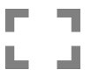Full Screen: You can expand Teipio Testun from the browser window to fill the screen. This obviously makes everything larger but also has the benefit of covering other windows and controls, and so makes the content simpler. Some browsers do not allow this feature. Pressing F11 in many browsers has a similar effect, called “kiosk mode”.

Two languages are available on the Welcome screen: English and Welsh. This affects the menu options and also the actual typing exercises. Accented character lessons are only available in Welsh.

Typing exercises are normally provided for two hands, but you can also choose only left hand or right hand. This significantly changes the screen layout and the early exercises.

For convenience there is an audio mute icon on the main exercise screen. This stops all speech and sound effects.

Skip line (*Pasio Llinell)* allows the user to jump through an exercise without typing each line. This is available at the bottom of the main exercise screen, if the option is enabled.

Words per minute *Geiriau y funud (GYF)*: This figure is shown with the Accuracy score, but is never shown for early exercises, to avoid distracting the user from accuracy.

Navigation from the main exercise screen back to the Options screen is possible by clicking on the cog icon.  
Navigation from Options back to the Welcome screen is possible by clicking on the back icon.

Users can proceed from score sheet to the next exercise, or repeat the current exercise, depending on their accuracy. The threshold is 90%.

If learner has assistive software providing magnification installed on their computer, it will probably clash with Teipio Testun and should be disabled.

## Keyboard Navigation

You can also use keys Tab, Space, Arrow Keys and Enter to navigate the Options screen, instead of clicking with the mouse. This will require plenty of practice before the learner is ready to use it. However, the low vision user should become a more independent user of Text Type/ Teipio Testun.

The keystrokes are standard for your web browser. This is simpler than most external screen readers, but still requires a good mental model of the system.

* Tab will move the highlight round the top level of selectable items.
* Right Arrow or Down Arrow will highlight the next option in a group of “radio” buttons, such as the list of exercises. Left Arrow or Up Arrow will move the highlight back within a “radio button group”.
* Enter selects a button, is like clicking it with the mouse.
* Space changes or selects an option. On checkbox options, it toggles them on or off.
* Escape returns from the main activity screen to the options. If the screen reader is speaking, it interrupts it. When in full-screen mode, the first press of Escape exits that mode.

Note that the list of exercises is made up of “radio buttons” where only one can be selected. The keys to navigate radio buttons are different from the keys for checkboxes, in most browsers.

## Keyboard Input Method

Text Type/ Teipio Testun does not control the input of characters like ê ó. It is necessary to ensure that the keyboard input region in Windows is set to CYM. This is normally shown in the bottom right of your screen.



On Microsoft Windows, you can change the settings in: Settings → Time & Language → Language → Keyboard. You should choose; Welsh - United Kingdom Extended.

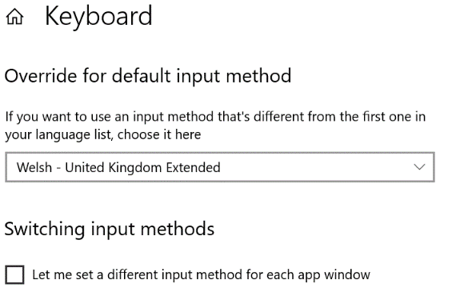

Please do not enable “Let me set a different input method for each app window”. This becomes very confusing and it can be difficult to type in the language you intend. This is not part of Text Type/ Teipio Testun, but is in the Microsoft operating system.

It is different again on ChromeOS.

The auto-repeat speed of your keyboard can also be changed in the operating system control panel. You can also enable “Sticky Keys” for single handed users, and several other accessibility features in the Microsoft Windows settings. Sticky Keys are described below.

Please ensure your physical keyboard is comfortable and usable.

### To Bach

There is an alternative software application for older versions of Microsoft Windows, to enable entering the accented characters like ê, ŵ. However, it is different from the Microsoft CYM method described above. It is a software application called To Bach, freely available from Interceptor Systems. The lessons at Welsh exercises 31 and 57 teach the key combinations for the Microsoft CYM method. If using the To Bach software, please skip those exercises but use the practice keyboard with personal support from a teacher.

## Accessibility Features

Zooming of text sizes is available using the “Show keyboard” and “show hands” options, and with the Full screen icon. Text Type/ Teipio Testun always zooms in to fill the window in the 16:9 shape of a normal computer screen.

Colours can be chosen with Highlight colours and Background styles.

Speech is typically used to prompt keys to type, actually typed, and for the screen reader, if available on your computer.

Navigation using the keys is possible between the Title Screen, Options Screen and Results screen using the standard keys for navigating a web page, as described above.

The supported hardware platforms for Teipio Testun are:

* Latest Chrome and Microsoft Edge web browsers.
* Windows 10 based PC computers and laptops with a real keyboard, set to the CYM region.
* Chrome OS Chromebooks with a real keyboard, set to the GB region.

## Scoring, Accuracy and Words per minute

Typing accuracy (*Cywirdeb*) is important and it must take precedence over typing speed. We recommend that users aim for better than 94%. That is sufficient for a learner to move on to the next exercise. They are unlikely to need more practice on the current exercise.

If a learner scores 90% or above, they may have had enough practice to move on. However, it should the decision of the teacher whether they do advance to the next exercise.

WPM, words per minute (*Geiriau y funud*) is an estimate of the rate at which the learner types. It's a simple calculation; the number characters typed in a minute divided by six. This is not shown until the results screen of Exercise 22, when all the characters have been introduced.

Accuracy is much more important than words per minute. It is best if the learner can type accurately at a regular pace, even if slow. They can always speed up through practice. There is no reason for a typist who has achieved 16 words per minute to still be using Text Type/ Teipio Testun. They have almost attained the speed that the average 18 year-old student can write by hand in exam conditions.

## Caps Lock

The Caps Lock key is not one that is used in Text Type. It is easily pressed by mistake in typing generally and while using Text Type. It is not recommended for typing capital letters, even for single handed users (who should use Sticky Keys on their computer settings).

Typing a capital letter at the wrong time is not accepted by Teipio Testun.

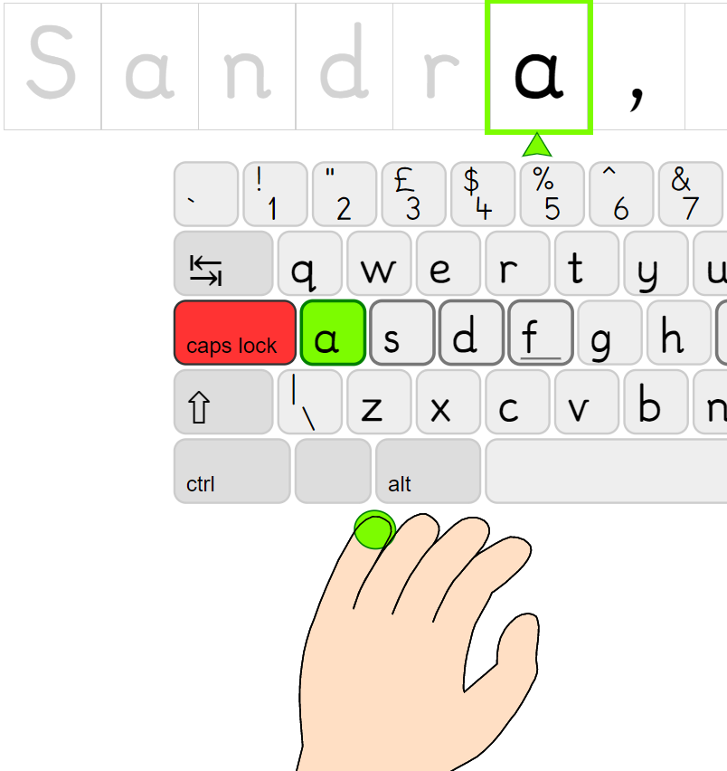

When Caps Lock is pressed, a warning is spoken by the secondary voice. “Caps Lock. Warning, Caps Lock is on”. If you persist in typing it warns, in the case shown, “Capital A. Warning. Caps Lock is on.” When you release Caps Lock by pressing the key again, it reports the key press, “Caps Lock”.

# Single Handed Typing

Text Type/ Teipio Testun has a method for teaching a single-handed user to type. Please select this from the first screen of Teipio Testun. In Welsh, *Llaw chwith* or *Llaw dde*.

It cannot teach full “touch typing” for one hand. The learner has to cover the whole width of the keyboard using a single hand. This cannot be learnt without some visual guidance.

The technique differs markedly from the standard typing.

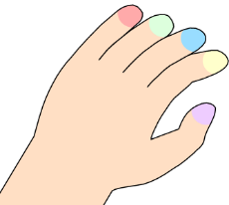

* The hand is held at a different angle, as in the diagram above.
* To reach the whole keyboard, the hand moves to right and left along the row of the home keys.
* The home keys are not all next to each other. They are S D F H for the left hand.
* Only one Shift key is used.
* ‘Sticky Keys’ needs to be set up on the computer so that capital letters and accented letters can entered using single key presses.

Colour is used for an entirely different purpose from the two-handed prompts. The colours indicate the finger to be used; the thumb in purple, and other keys yellow, blue, green and red respectively. This colour scheme was originally devised for a young hemiplegic learner who started out with small stickers of these colours on her four fingernails! It worked.

## Sticky Keys – *Bysellau Gludiog*

“Sticky Keys” is a feature of most computer operating systems, to support typing by pressing only one key at a time. It effectively locks down modifier keys like Shift, until you press the next key.

For the single-handed typist, it is very important to understand and master Sticky Keys. Shift and Alt Gr are modifier keys that produce no text of their own but should be pressed at the same time as another key. Normally, holding down Shift then pressing A will produce capital A but requires two hands. Using Sticky Keys, you can press Shift, release it, then press A. Likewise with Sticky Keys for the Welsh accented characters, pressing and releasing Alt Gr then 6 then A will produce â.

The easiest way to enable Sticky Keys in Windows is usually to press the Shift key five times. A sound effect will play and you will see this message:

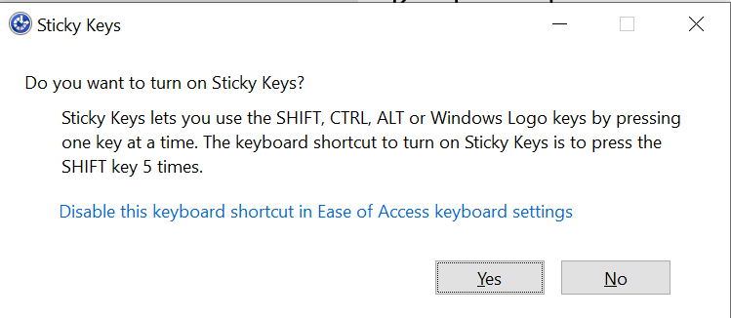

However, this can be a frustrating experience when you first use it. Making a mistake such as pressing Shift key twice can result in Sticky Keys being cancelled and the learner having to press the Shift key five times again.

You can also also enable Sticky Keys in the Settings of Windows. Click on the link in the window above. These are the recommended settings:

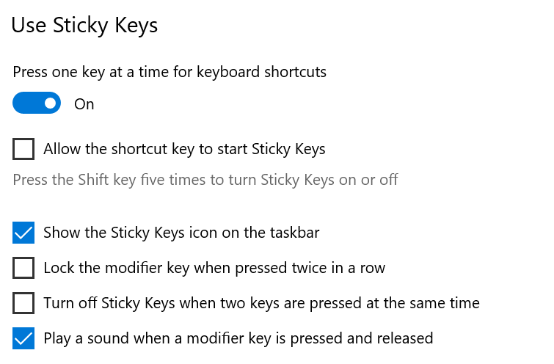

Once the learner no longer needs the sound indicating that Sticky Keys has been activated for the next keypress, it may help to turn it off.

If the user has to log in to the computer and share it with other people, it may or may not be possible for the system to remember this setting. It depends on the local IT policy.

In Microsoft Windows 11, this has been changed again. “Ease of Access” is now called “Accessibility”.

## Single-Handed Exercises

The early exercises to practise the letters are different in Teipio Testun between two hands and single left or right hands, *Llaw chwith* or *Llaw dde*. There are specific exercises for each hand until Exercise 16, where capital letters are introduced. After that, the exercises are the same.

The first exercises are aimed at learning the middle row. The home keys are introduced, and the remaining keys added gradually.

Beyond exercise 16, Text Type/ Teipio Testun works very much as it does for two-handed users.

The single-handed exercises in English are different from those in Welsh.

# The role of the teacher

Text Type/ Teipio Testun has enhancements to allow VI learners to navigate it, but it is not suitable for unsupervised self-instruction. The role of the teacher is to assess and guide. This can happen at these points:

* Working with a VI learner, the teacher will need to assess the amount of support to give on the Options page; deciding on the best coloured highlight, background and display options, whether Screen reader Speech needs to be turned on.
* If the learner has very low vision they might need to navigate Teipio Testun using the keyboard with Tab, Arrow Keys and Enter. This skill is best taught using the Practice Keyboard with Speech on.
* Working with a single handed user, the teacher will need to show the learner how to set up sticky keys. Even better in the case of a personal laptop or login to a network, set this up so that it engages at login.
* When a learner starts on Teipio Testun, the teacher assesses their level. This may be to start away from the keyboard, with fingers on a desk as described above. It may be to practise getting their fingers in position using the Practice Keyboard.
* When the learner starts on the exercises, it’s important to check that they are typing at an even pace, not rushing through the mastered keys and slowing down considerably for the less familiar keys.
* The decisions to progresses through the exercises should not only be according to the score that Teipio Testun gives. Certainly, an accuracy score of 94% will earn the learner the right to advance to the exercise. Scores between 90% and 95% are less straightforward and the teacher should be consulted.
* If the learner has just completed one of the tutorials, capital letters or accented characters, the teacher needs to make sure that the learner is not needing extra practice.
* Keeping an eye on the Words Per Minutes rate is a useful form of assessment. Once all the letters, capitals and to bach accents have been practised, The WPM rate is displayed on the score screen.

Any WPM rate between 6 and 10 is acceptable at this stage.  
A rate of 4 or less suggests that the learner is needing some attention.  
A learner scoring 11 or 12 will outstrip the voice speaking the target letter. The focus should be on typing to a steady beat.   
A faster WPM of 14-15 signals that the learner is ready to type independently outside Text Type/ Teipio Testun.

## Finally

We are proud to have been commissioned by the Welsh Government to create Teipio Testun, a typing tutor completely in Welsh. We believe that young visually impaired learners whose first language is Welsh will benefit greatly. We have added features to give access to touch typing practice to those learners with the lowest levels of vision.

Best wishes from the Teipio Testun team. Dymuniadau gorau.